**Home Insurance Application**

**User Guide Document**

**For ASP.Net MVC**

**Purpose of the document:**

*Intention of this document is to guide the user to effectively use the application. The logical arrangement of the information and screen prints shall enable the user to understand the sequence and navigation of the system.*

*Connecting to the application:*

*You must start the application in visual studio:*

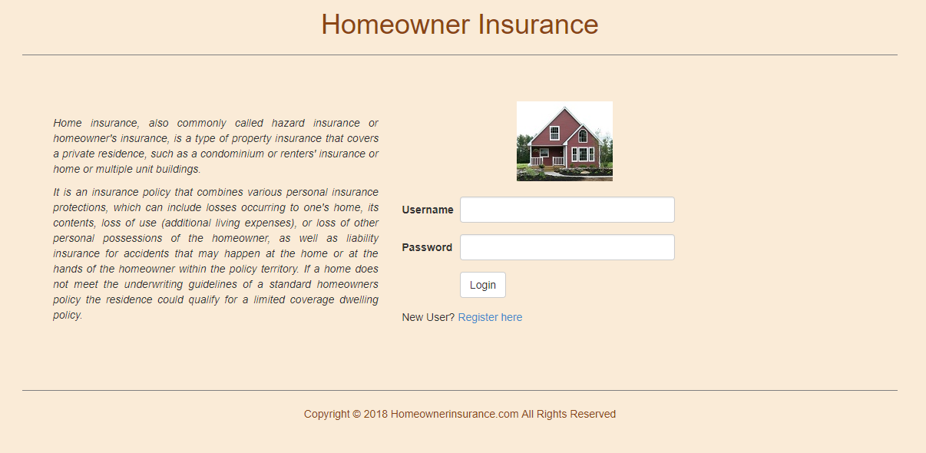

*Fig 1*

1. *Authentication :*

*User can login as* ***User*** *or* ***Admin*** *as per their authority. First we will go through User login and check all the functionality of a user login.*

1. *New User Registration:*

*New user can be enrolled to the application by clicking* ***Register here*** *link (fig 1). User will be guided to fill in the registration form (fig 2).*

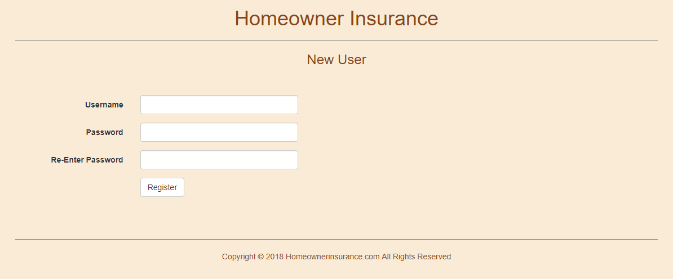*Fig 2*

*User has to fill in all the mandatory field, not doing so will lead to error messages appearing on the screen to pop up. Refer to fig 3 when user leaves Username field blank, error dialog pops up.*

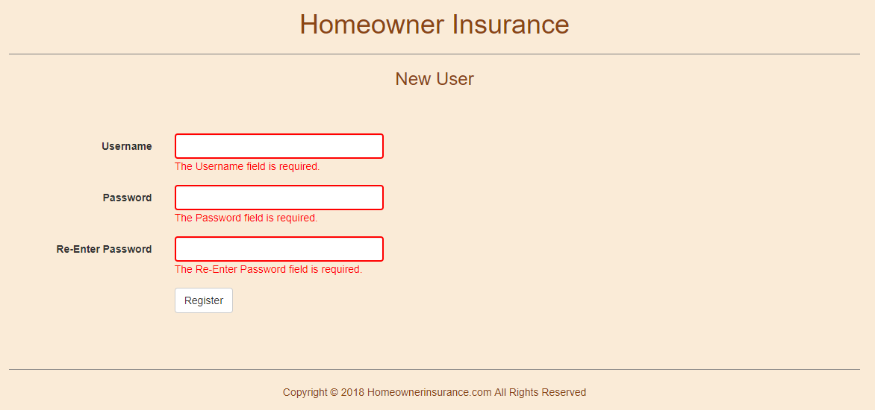

*Fig 3*

1. *Logging In as User:*

*User can login to the application using the same username and password used for registering. If user enters wrong credentials he will be prompted with error message as in fig 4. If right, go to fig 5.*

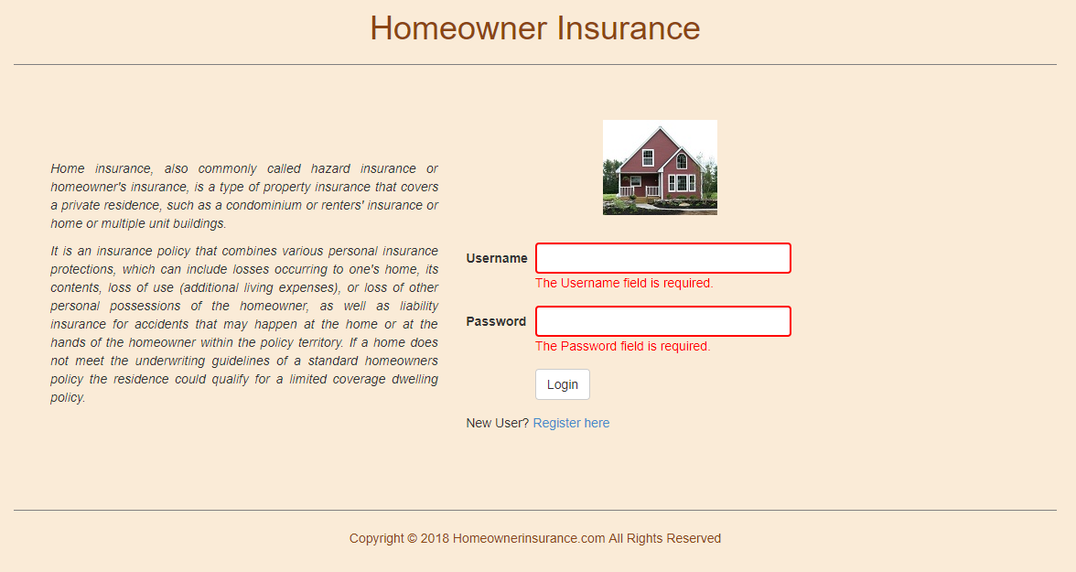

*Fig 4*

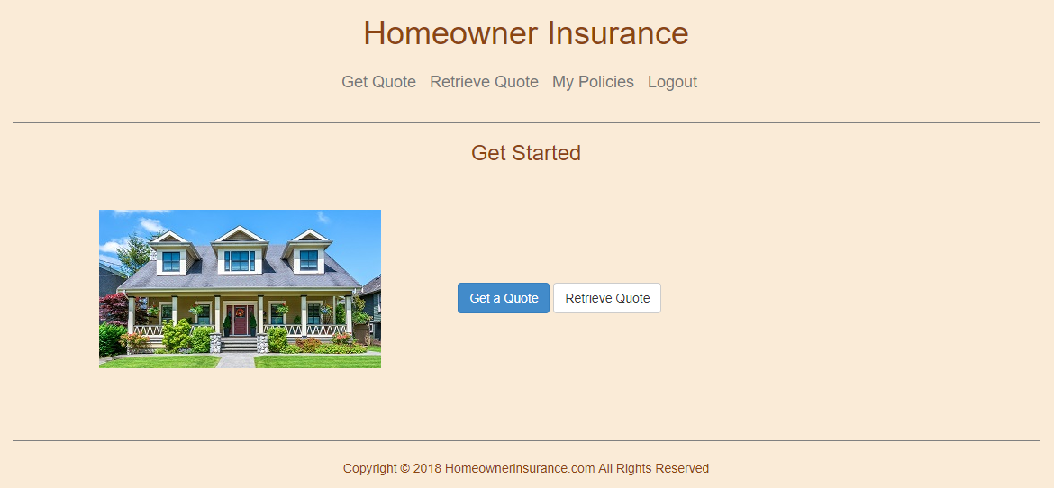

*Fig 5*

1. *Get a Quote:*

*Once user successfully logged in, user can submit his quotation by clicking the “Get a Quote” button on the Get Started Page. Once user clicks “Get a Quote”, redirect the user to the Homeowner Page (fig 6).*

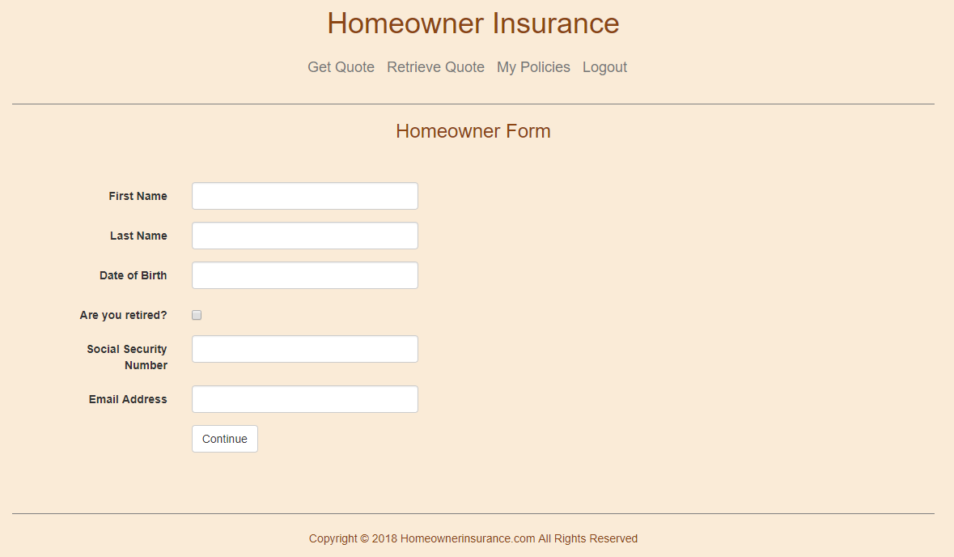

*Fig 6*

1. *Homeowner Form:*

*In this Page, user has to enter all of the mandatory fields. If user enters any blank fields or invalid, display an error message (fig 7).*

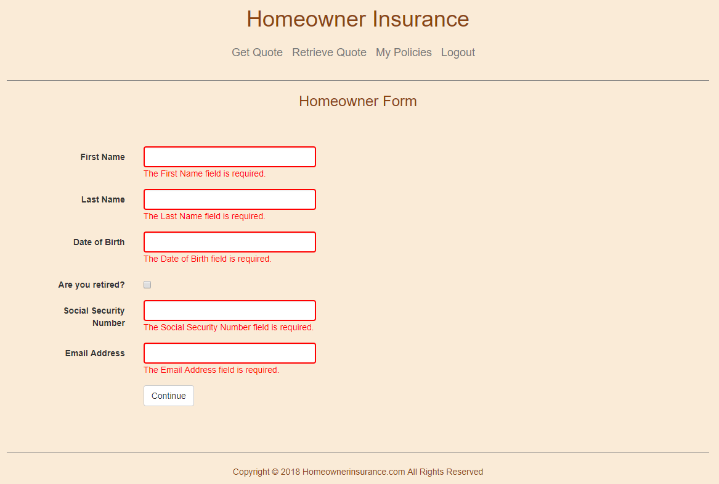 *Fig 7*

1. *Location Form:*

*Once the user submits from Homeowner Form, redirect to the Location Form. In this Page, user enters all of the mandatory fields. If user enters any blank fields or invalid, display an error message (fig 8).*

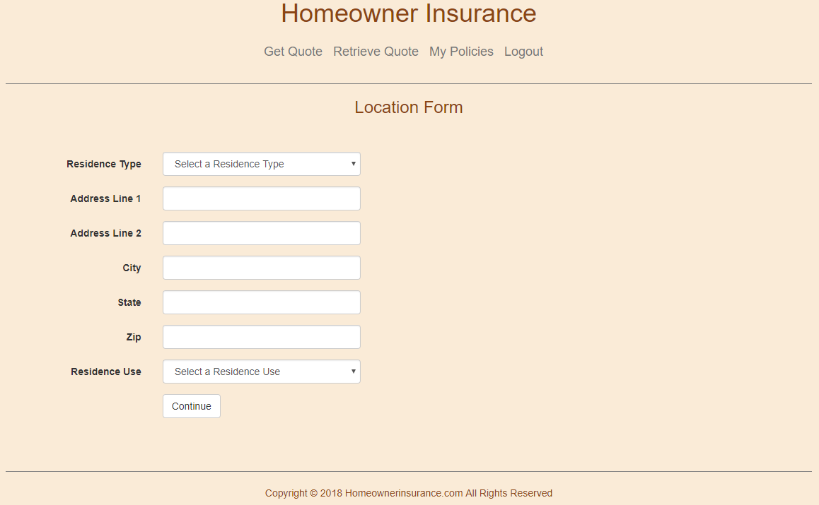

*Fig 8*

1. *Property Form:*

*Once the user submits from Location Form, redirect to the Property Form. In this Page, user enters all of the mandatory fields. If user enters any blank fields or invalid, display an error message (fig 9).*

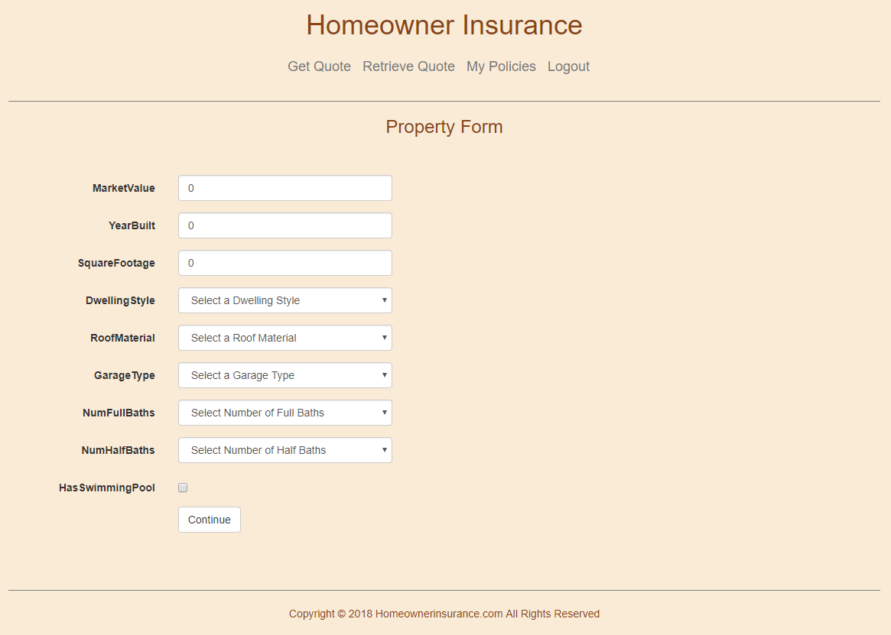

*Fig 9*

1. *Coverage Details:*

*Once the user submits from Property Form, redirect to the Coverage Details Page. In this Page, user will get their quote information calculated and displayed. (fig 10).*

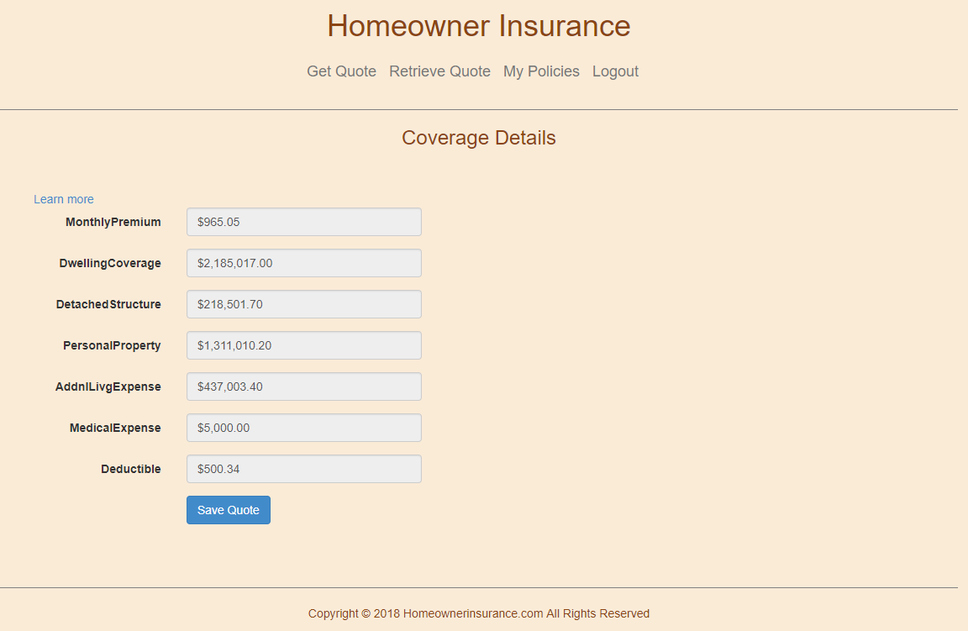

*Fig 10*

1. *Quote Terms: User gets additional information on all the calculations by clicking Additional info link (fig 11).*

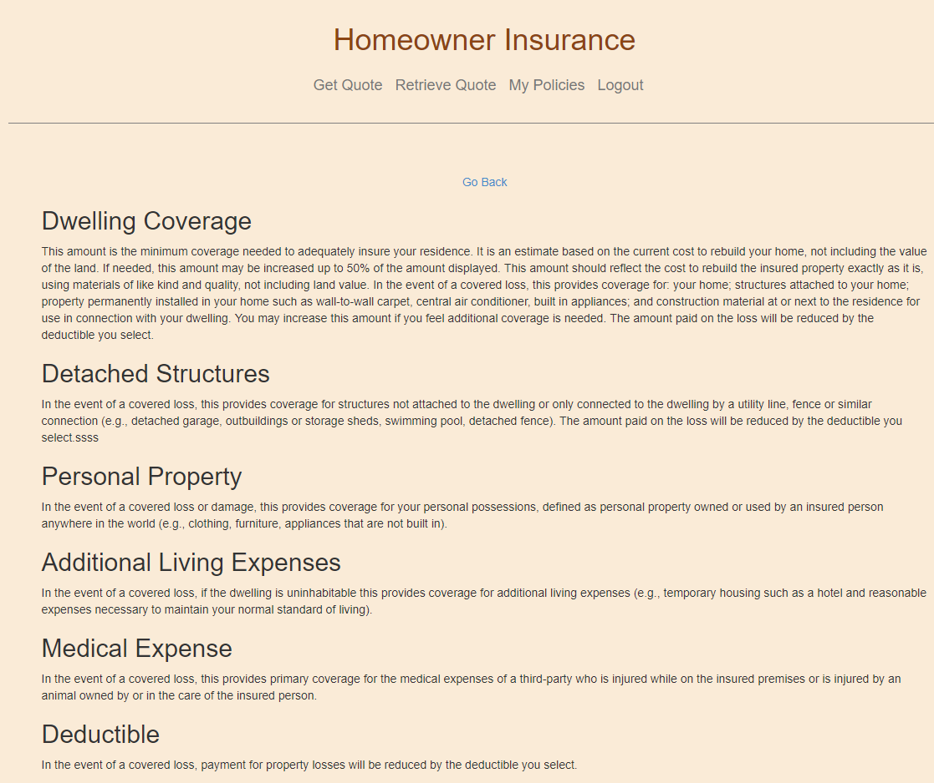

*Fig 11*

1. *Retrieve Quotes (or Quote Details):*

*If user is interested, they can click proceed to buy. User can click on the link below (fig 12) to see the quote summary and then purchase a policy.*

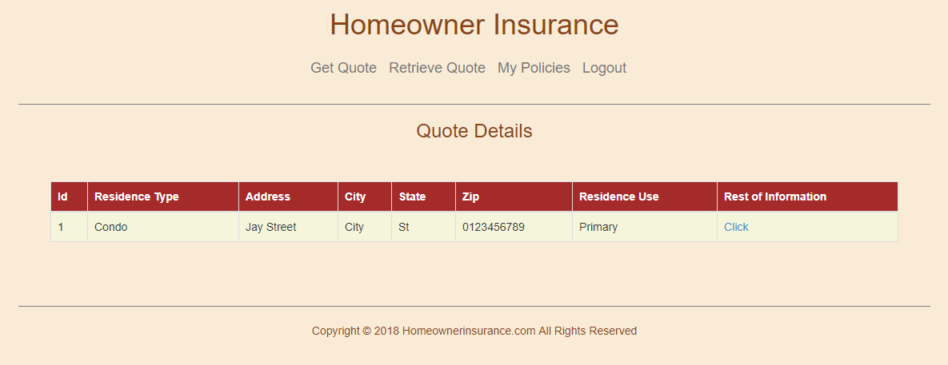

*Fig 12*

1. *Quote Summary:*

*In Quote summary page, the user can check their monthly premium, Location details, Homeowner details, Property details and Coverage details (fig 13). Click Buy Policy to go to the next page.*

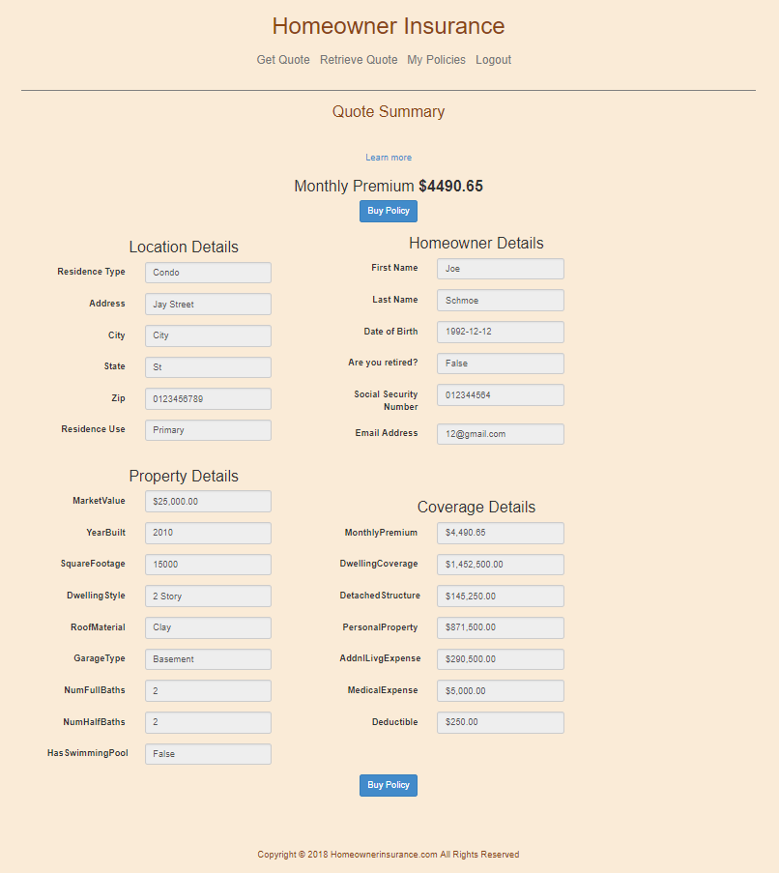

*Fig 13*

1. *Buy Policy:*

*Must enter a date from which he has to start the policy (less than 60 days) fig 14.*

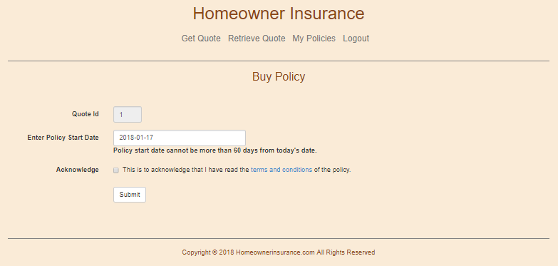

*Fig 14*

*Provide a link for the user to read the terms and conditions (fig 15). Must click on the checkbox before pressing the submit button.*

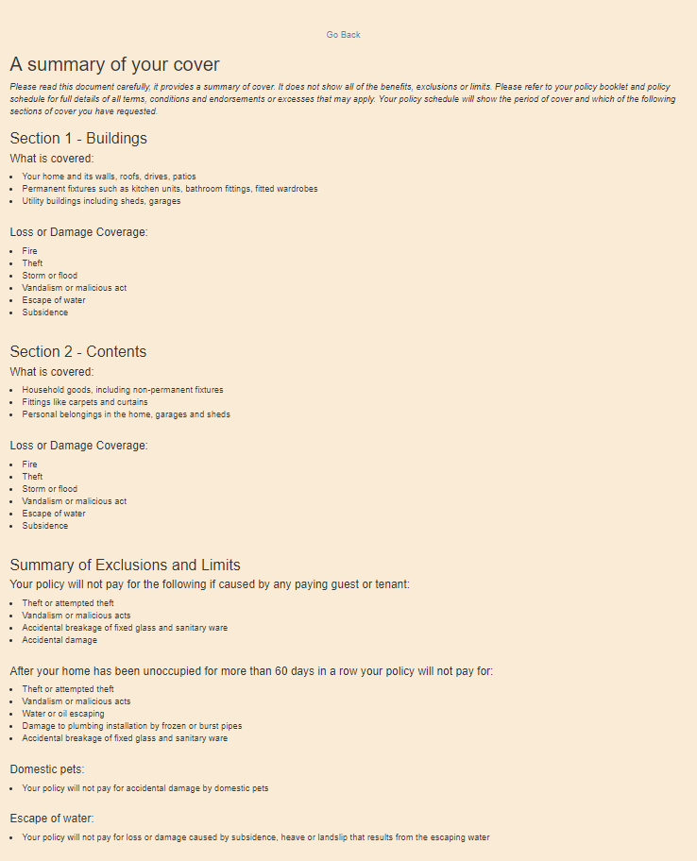

*Fig 15*

1. *Policy Confirmation:*

*In policy confirmation page user can check his policy details. (Fig 16)*

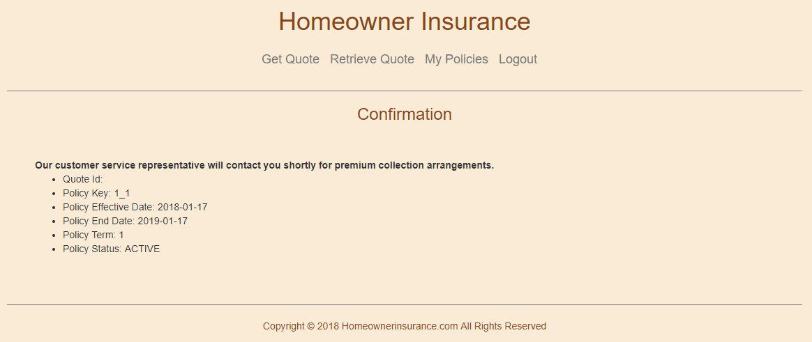

***Fig 16***

1. *Admin Login (or Search User):*

*User needs to admin credentials in order to log in and be redirected to the Admin page (fig 17) wherein he can search for a user by entering their username.*

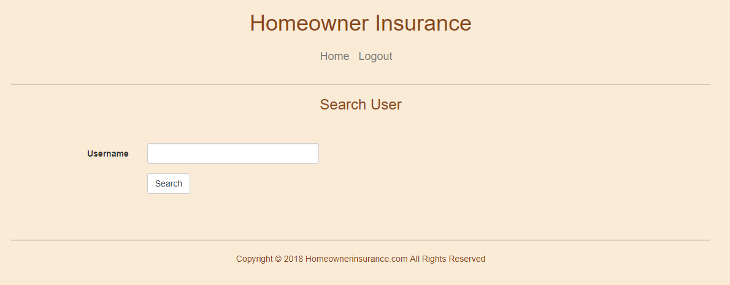

***Fig 17***

1. *User Policies*

*In User Policies, the user admin can either renew a policy or cancel a policy by clicking on their respective links (fig 18).*

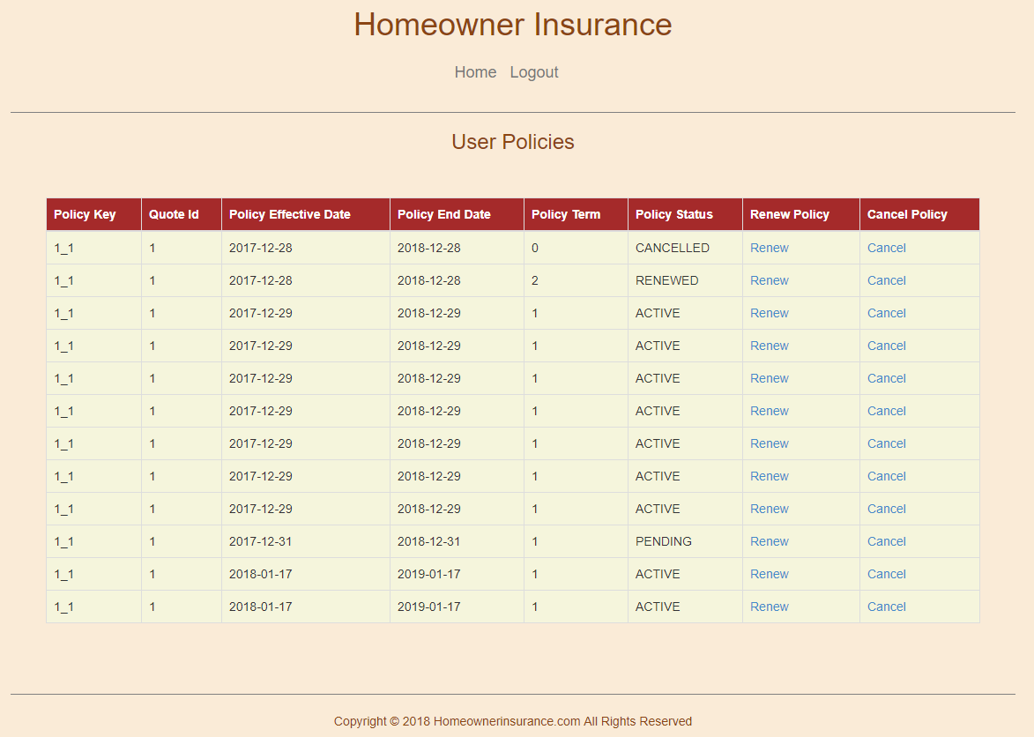

***Fig 18***

1. *Renew User Policies*

*If the admin renew a policy he will be getting a confirmatory message and a new page with renewed policy details (fig 19)*

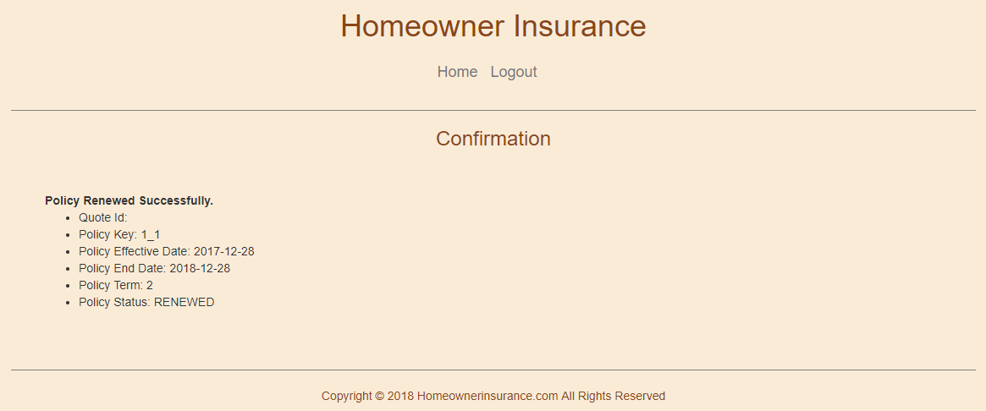

***Fig 19***

1. *Cancel User Policies*

*If admin cancels a policy he will be getting a confirmatory message and a new page with cancelled policy details (fig 20).*

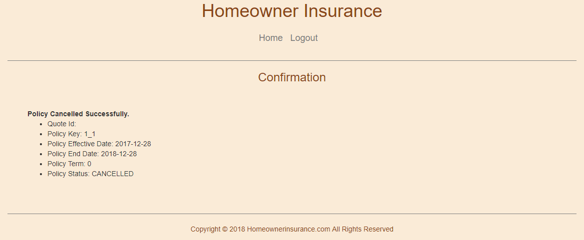

***Fig 20***

1. *Logout User*

*If user clicks on the Logout link on the navbar, they will be redirected to this page and be offered the chance to log in again.*



***Fig 21***